Possible Responses to:
STUDENT SHEET 3.3: Genetic Exposures in the Smoking Behavior Study

As a class, look at Question 103 in the Hypothesis Testing view of the smoking behavior database. Under “3. Identify answers corresponding to your exposure,” there is a list of four possible answers for the C957T region of the DRD2 gene. Work with your class to answer the questions below.

- How many possible genotypes (combinations of genes) are there for this gene region?
There are three possible genotypes, C/C, C/T, and T/T.

- Why does each genotype have two letters associated with it (C/C, T/T, C/T)?
People have two copies of each gene, one inherited from their mother and one from their father.

- DRD2 is on the long arm of chromosome 11, shown by the arrow at the left in the figure below. Draw the genotypes on the chromosome pairs, as shown in the example at the left. Why are there two chromosomes for each genotype?

C/C T/T C/T


C
C
DRD2
T
T
C
T
There are two chromosomes for each genotype because we have two copies of each chromosome.

- DRD2 codes for the dopamine receptor. The T allele of the C957T gene region results in fewer receptors than the C allele. Draw the number of receptors you expect for each genotype in the diagrams below. One receptor is shown in each figure.
C/C would have the most receptors, T/T the fewest, and C/T an intermediate amounts
C/C T/T C/T

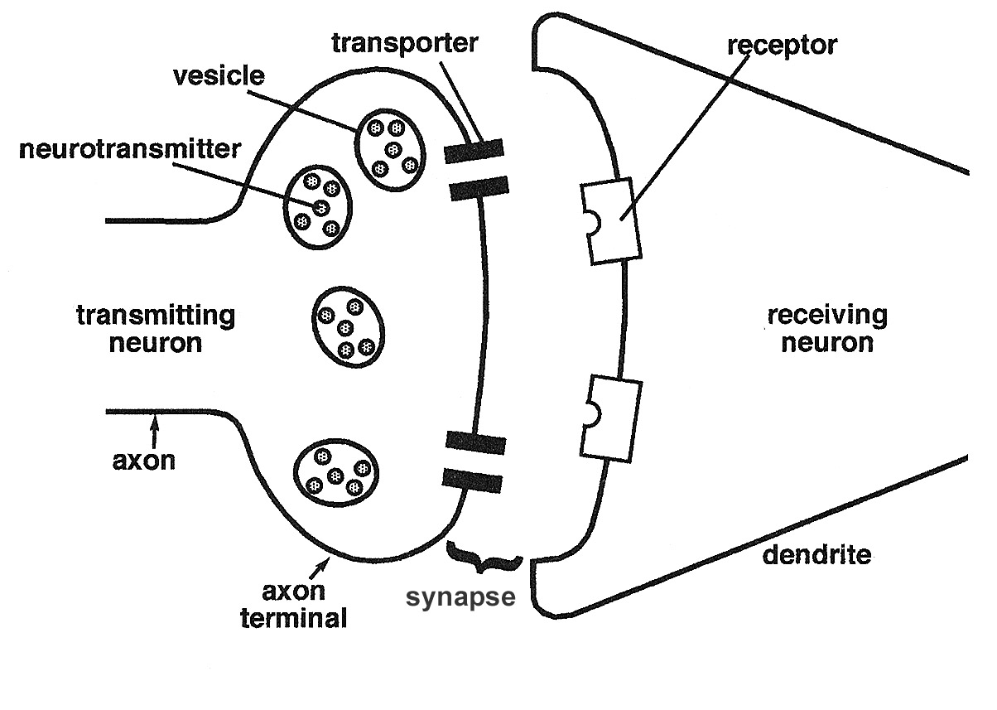

- You just learned that the DRD2 gene codes for the dopamine receptor. What is the function of this protein? How might making less of this protein (compared to “normal”) affect a person’s smoking behavior? (Hint: Think about the giant neuron and the effect of nicotine on dopamine release).
The dopamine receptor is located on the post synaptic neuron, and it binds dopamine that is released into the synaptic cleft. This has an effect on neurotransmission on that neuron.
Making less of the dopamine receptor may result in a person who is a smoker smoking more cigarettes than someone who has more receptors in order to feel the effect of nicotine.
Note: Students may also say that people who make less of the dopamine receptor are less likely to become smokers because they may not be able to stimulate their reward pathway. There is no right answer to this question—students should provide a reasonable justification for their response.

- What protein does the DDC gene code for? What is the function of this protein? How might making less of this protein (compared to “normal”) affect a person’s smoking behavior?
DDC codes for dopa decarboxylase. This enzyme is part of the dopamine synthesis pathway. Making less dopa decarboxylase may result in a person having less dopamine in their neurons. People who make less dopamine may smoke more than people with a normal amount so that they can stimulate their reward pathway.
Note: Students may also say that people who make less DDC are less likely to become smokers because they don’t get much stimulation of their reward pathway from smoking. There is no single correct answer to this question—as in question 5; the important thing is that students provide a reasonable justification for their response.
7. Several of the questions in the questionnaire may have a physiological/genetic component to them, even though there is not a specific gene mentioned. Identify at least three questions that may be asking about something that is partially or largely genetic, and discuss why you think this for each question.
Possible responses include:
- Q18. Each part of this question refers to a physiological sensation as a result of smoking, and these sensations would be determined mainly by genetic factors.
- Q26 and 28. Having parents or siblings who smoke may also have a genetic component because we share many of the same gene alleles with our parents and siblings.
- Q67. Frequency of drinking alcohol. There may be a physiological aspect to whether a person drinks or smokes, and these may be related.
- Q68-70. Satisfaction with life, stress, and self esteem as a teen may have both physiological and environmental components.

