Name: Email: Class:

Student Road Map The Microbiome: Food, Fiber, and Fitness

Driving Question: How do food choices and the environment affect the gut microbiome in humans?
By the end of this lesson, we hope that you have learned:
- A healthy a gut microbiome is a diverse, complex ecosystem.
- The foods you eat feed your microbiome, and your microbiome thrives on fiber.
- Diet can affect your microbiome in ways that can increase or decrease the likelihood of type 2 diabetes and other metabolic diseases.

In today’s lesson, you will: |  |  | Time
1. | Get to know the microbiome by picturing yourself in a rainforest | 3 minutes
2. | Watch a 5-minute video about how the food you eat affects your gut | 7 minutes
3. | Do Simulation 1: Your microbiome and random chance | 10 minutes
4. | Watch a 4-minute video about why fiber is good for you | 6 minutes
5. | Do Simulation 2: Your microbiome and choice | 10 minutes
6. | Data Drop: The microbiome and type 2 diabetes | 10 minutes

Before we start: Study of the microbiome is a relatively new field and doors are opening to new areas of research. Changes in the microbiome have been associated with metabolic diseases such as obesity and type 2 diabetes, as well as linked to mental health, autism, Parkinson’s disease, cancer, and many more conditions. This complex topic leads to many questions, including an important one about causation: Do certain diseases change the microbiome, and/or does a change in the microbiome play a role in causing to the disease? While scientists are working on this question right now, we don’t have many solid answers.

Lesson credits: This lesson is based on a presentation by Cecilia Noecker, PhD, University of Washington. Special thanks to Alex Eng, PhD, and the following teachers: Jim Christian (Colville High School), Amy Hoffman (Kingston High School), Valerie Merrill (Redmond High School) Dawn Rubstello (Roosevelt High School), and Loren Shaw (Glide High School)
This lesson contributes to student competency in the following standard:
HS-LS2-6: Evaluate claims, evidence, and reasoning that the complex interactions in ecosystems maintain relatively consistent numbers and types of organisms in stable conditions but changing conditions may result in a new ecosystem.

- Get to know the microbiome by picturing yourself in a rainforest
Imagine you are in a rainforest. It is hot, it is humid, and you can taste the air. There is green all around you, and so many kinds of trees and plants you cannot count them all. Some have red fruits, and some have tiny purple flowers. And the animals! There are birds, bats, squirrels, and monkeys. Mosquitoes are buzzing in your ear, and a giant Goliath beetle is quietly walking over decaying leaves on the ground. The sheer diversity is overwhelming, and it is almost impossible to describe how all these living things are connected.
The rainforest is an intricate web made of prey, predators, parasites, producers, and consumers. In this complex ecosystem, food and nutrients cycle from one organism to another organism.
Now imagine that same rainforest, but inside of your gut. It is still hot and humid but instead of plants and animals and insects, you have microbes. These are tiny creatures that all look the same under a microscope but are just as different from each other as birds and bats and squirrels and monkeys. It is a diverse, interconnected, and relatively unexplored place. Your gut is one of the most complex ecosystems on the planet.
The microbes in your gut do the same things that other living organisms do: They eat. They reproduce. They give off waste. They are part of a complex ecosystem in which food and nutrients cycle from one organism to another. One microbe’s trash may be another microbe’s treasure.
One key to health for both the rainforest and your microbiome is the diversity of living things that make up the interconnected web. If half of the trees were removed from a rainforest the balance will be upset for the remaining species. Some will die, and others will become overgrown. The same is true for the microbes in your gut.
We have a mutually beneficial relationship with most of our gut bacteria. We provide food, shelter, and a safe habitat. In return, they digest foods for us and produce nutrients we need.
How do we maintain a diverse and healthy microbiome? We feed it the food it thrives on, which is fiber.
Storyline based on a TED talk by Katherine Amato
- How does the food you eat affect your gut? Watch this video to find out.
List 3 things you learned or found interesting in this video:

- Simulation #1: Your microbiome and random chance. You will begin with a randomly selected microbiome. You will experience some random changes to your microbiome based on your environment, food choices, or experiences. Download the Activity Simulator here.
Use the spinner to randomly find your starting microbiome.
Fill out the table below to record the number of microbes in your starting microbiome:

Starting Microbiome | Blue | Green | Orange | Gray
Microbiome #

Lots of things can happen to your microbiome! Spin the next spinner at least 4 times. After each spin, record the new number on the table. If a microbe does not gain or lose in that turn, keep the number the same for the next round.

What happened? | Blue | Green | Orange | Gray
Spin 1:

Spin 2:

Spin 3:

Spin 4:

In an experimental assay, we will measure the amount of Butyrate being produced by your microbiome after the last spin. Butyrate is a health-promoting metabolite we will learn more about later.

Experimental Assay | + 2 for each blue | -1 for each green | +3 for each orange | No impact for gray | Total Butyrate Score
Butyrate production |  |  |  | X

Blue and orange microbes produce Butyrate. Green microbes inhibit production of Butyrate by blue & orange. Gray microbes have no impact on Butyrate production.
- What is Butyrate? Watch The Hungry Microbiome to find out why resistant starch (type of fiber) are good for you. List three things that you found interesting or learned in the video.

- Simulation #2: Your microbiome and choice. You will begin with a microbiome you have selected. You will choose changes to your microbiome based on your environment, food choices, or experiences. Return to the Activity Simulator.

Choose a starting microbiome. Fill out the table below to record the number of microbes in your starting microbiome:

Starting Microbiome | Blue | Green | Orange | Gray
Microbiome #
Why did you choose this microbiome?

Choose 4 impacts to your microbiome. You may choose the same impact card multiple times. After each choice, record the new number on the table.

What happened? | Blue | Green | Orange | Gray
Choice 1:

Choice 2:

Choice 3:

Choice 4:

Why did you choose the cards you did?

In an experimental assay, we will measure the amount of Butyrate your microbiome produces.

Experimental Assay | + 2 for each blue | -1 for each green | +3 for each orange | No impact for gray | Total Butyrate Score
Butyrate production |  |  |  | X

Blue and orange microbes produce Butyrate. Green microbes inhibit production of Butyrate by blue & orange. Gray microbes have no impact on Butyrate production.
Comparing Simulations:
- How were your butyrate totals different between Simulation #1 and #2, and what caused the differences?

- What dietary and environmental choices affect the gut microbiome? List at least 4 ways.

- Data Drop: The microbiome and type 2 diabetes. In a 2017 study, the microbiomes of people with type 2 diabetes and health controls were compared.
A metabolite is a by-product or end-product of metabolism, the breaking down of food.

The top five frequently produced metabolites for (a) healthy controls, and (b) people with type 2 diabetes are shown below.

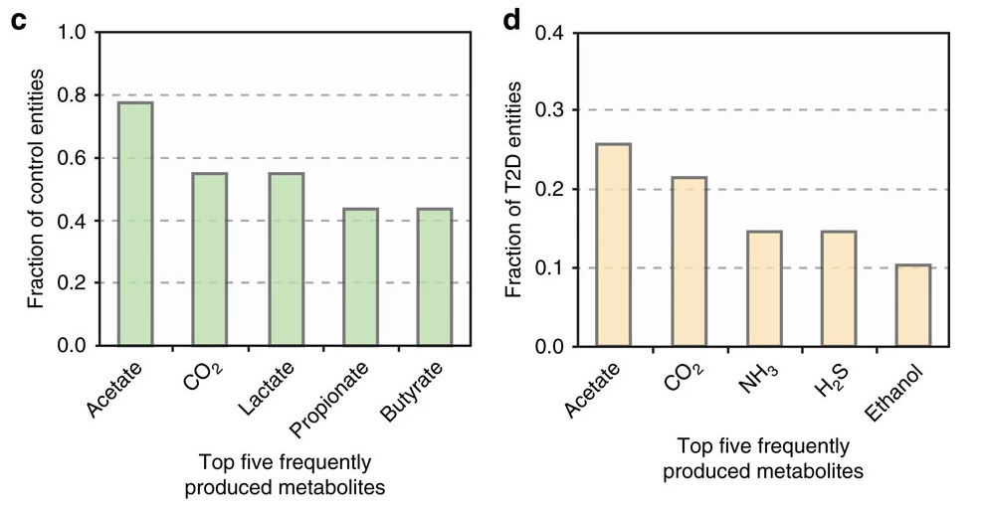

a. Healthy Controls
b. People with type 2 diabetes

Sung, J., Kim, S., Cabatbat, J. et al. Global metabolic interaction network of the human gut microbiota for context-specific community-scale analysis. Nat Commun 8, 15393 (2017). https://doi.org/10.1038/ncomms15393

- What do the graphs show?

Remember the rainforest, and the complexity and interconnectedness of the ecosystem? Here is the metabolic interaction network of the gut microbiome from the study referenced above for you to memorize. (Just kidding.) The orange dots represent microbes found in the guts of people with type 2 diabetes, and the blue dots represent microbes from healthy controls.

- Find Butyrate (in blue). List two microbes that produce Butyrate (written in black italics).

- What macromolecule (food) are some of them breaking down in the process?

- In our simulation, we used 4 types of gut bacteria. Approximately how many types do you see in the metabolic interaction network?

- What dietary choices do you make that affect your gut microbiome?

- How could you change your choices to preferentially select for beneficial microorganisms?

Take-aways for this lesson:

- The microbes in our guts break down food we cannot, and some of the by-products of metabolism (like butyrate) are helpful to our health.

- A high-fiber diet can promote the growth of a healthy microbiome.

- It is hard to know about causation: Does disease change the microbiome or does a change in microbiome contribute to disease? How do our diets and actions change our microbiomes, and how do changes in our microbiomes change our diets and actions? There is still a lot to learn.

- We know that our dietary choices influence our health.

